* **What is EFS in AWS?**

Amazon Elastic File System (EFS) is a fully managed file-level storage service that provides scalable, concurrent, and encrypted file storage within AWS.

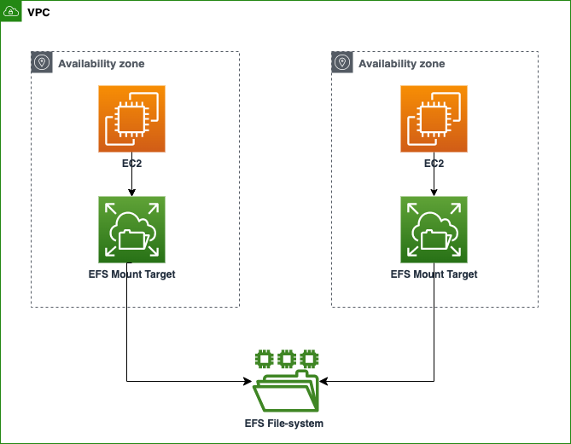

# **Lab Steps:**

## **Task 1: Sign in to AWS Management Console.**

1. Search aws console management in chrome.

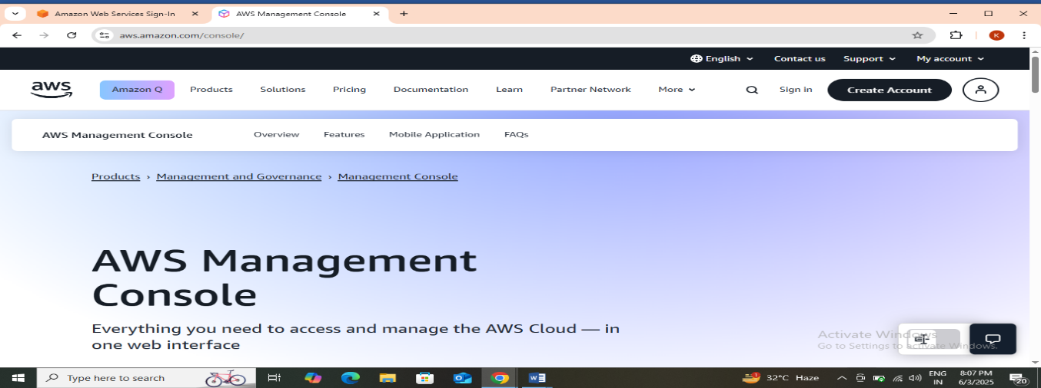

1. Then click on sign in. Now On the AWS sign-in page,

* Leave the Account ID as default. Never edit/remove the 12-digit Account ID present in the AWS Console. Otherwise, you cannot proceed with the lab.
* Now copy your **Username** and **Password** in the Lab Console to the **IAM Username and Password** in AWS Console and click on the **Sign-in** button.

1. Once Signed In to the AWS Management Console, make the default AWS Region as  **US East (N. Virginia) us-east-1.**

**Task 2: Launching two EC2 instances.**

1. Make sure you are in the **N. Virginia** Region.
2. Navigate to the **Services** menu in the top, then click on **EC2** in the **Compute** section.
3. Click on **Instances** from the left side bar and then click on **Launch instances**.
4. Number of Instances:  Enter ***2***on the right side under summary
5. Name: Enter ***MyEC2Instances***
6. **For Amazon Machine Image (AMI):** Search for **Amazon Linux 2 AMI** in the search box and click on the **Select** button

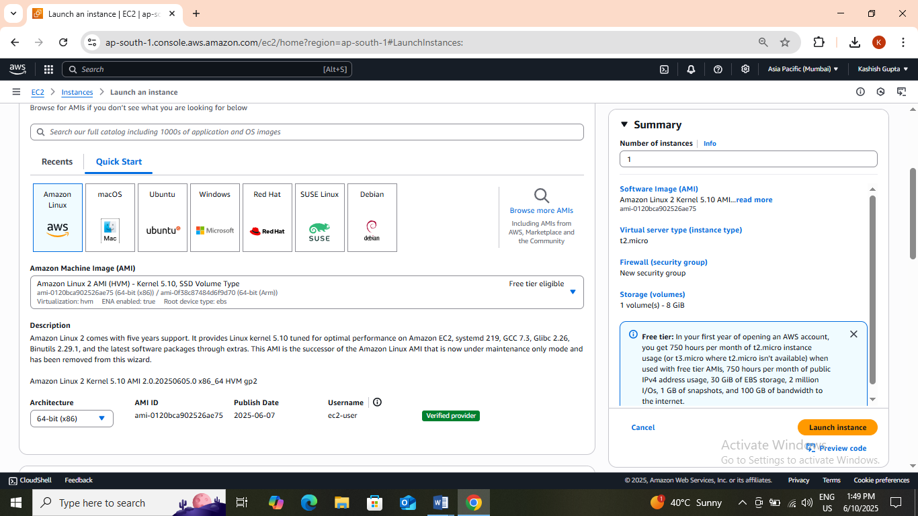

1. **For Instance Type:** select ***t2.micro***.

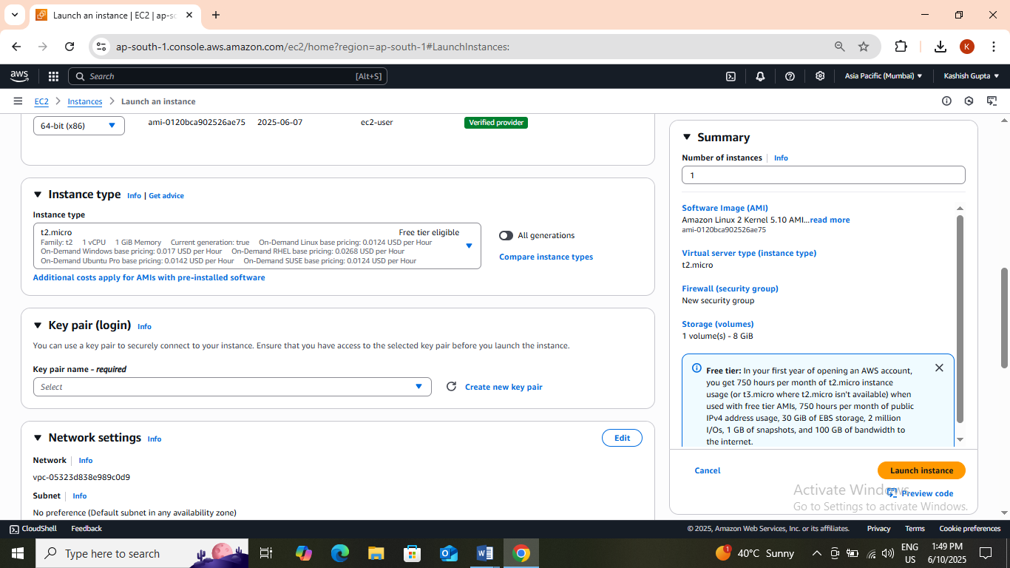

1. For Key pair: Select **Create a new key pair** Button

* Key pair name: **MyEC2Key**
* Key pair type: **RSA**
* Private key file format: **.pem**
* Select **Create key pair** Button.

1. In Network Settings Click on **Edit**:

* Auto-assign public IP: **Enable**
* Select **Create new Security group**
* Security Group Name: Enter ***EFS Security Group***
* In description: Enter **EFS Security**
* To add **SSH:**
* Choose Type: **SSH**
* Source: **Anywhere**
* Then click on **Add New Security Group.**
* To add **NFS:**
* Choose Type: **NFS**
* Source: **Anywhere**

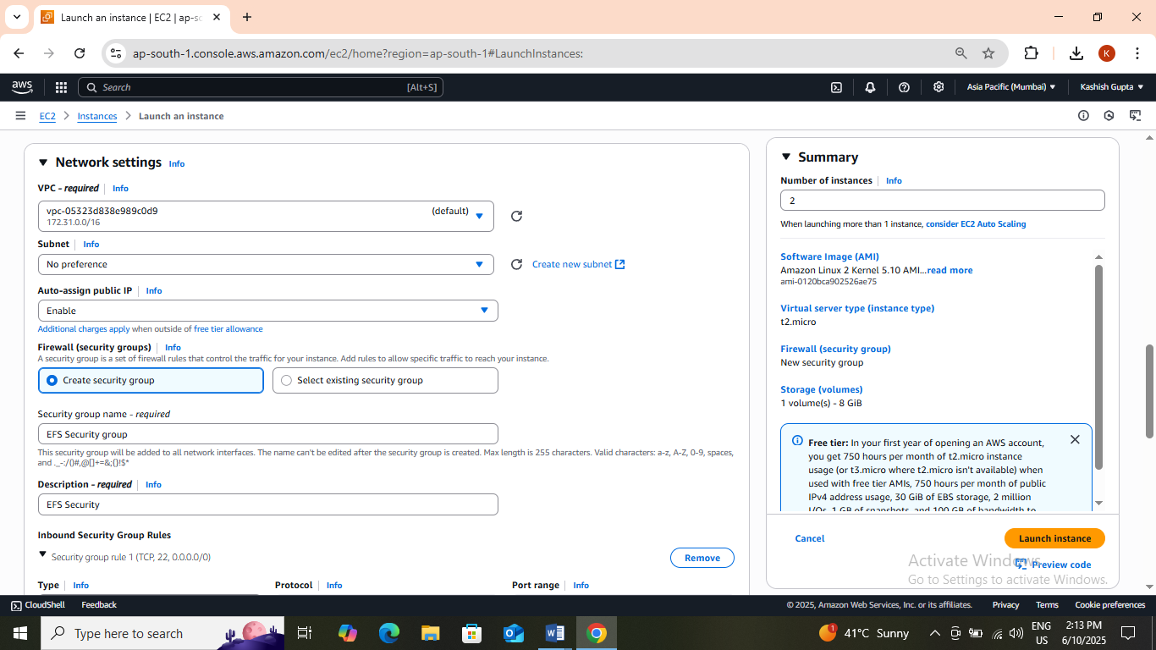

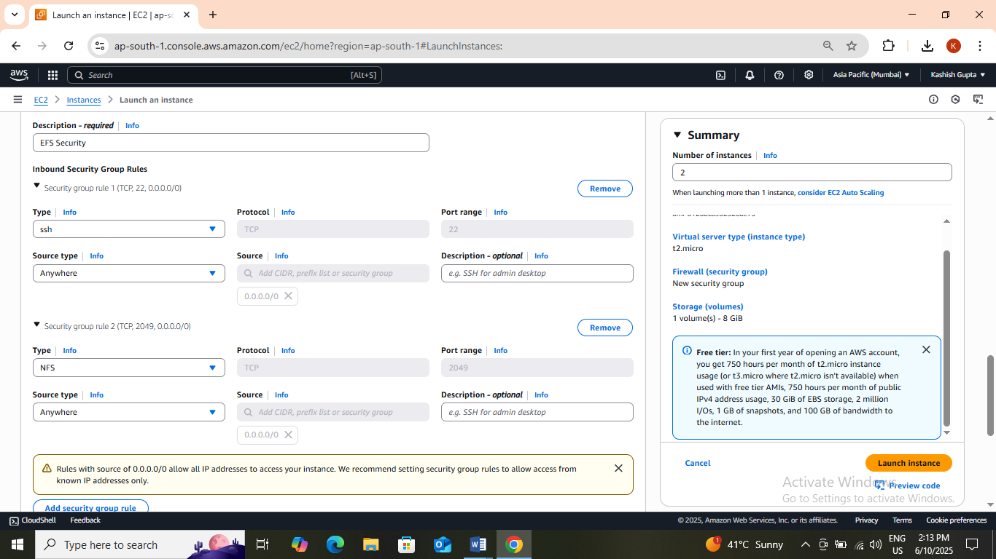

1. Keep Rest thing Default and Click on **Launch Instance** Button.
2. Select **View all Instances** to View Instance you Created.
3. **Launch Status:** Your instance is now launching. Click on the instance ID and wait until the initialization status changes to **Running.**

Click on each instance and enter a names as **MyEC2instance**and **MyEC2instance.**

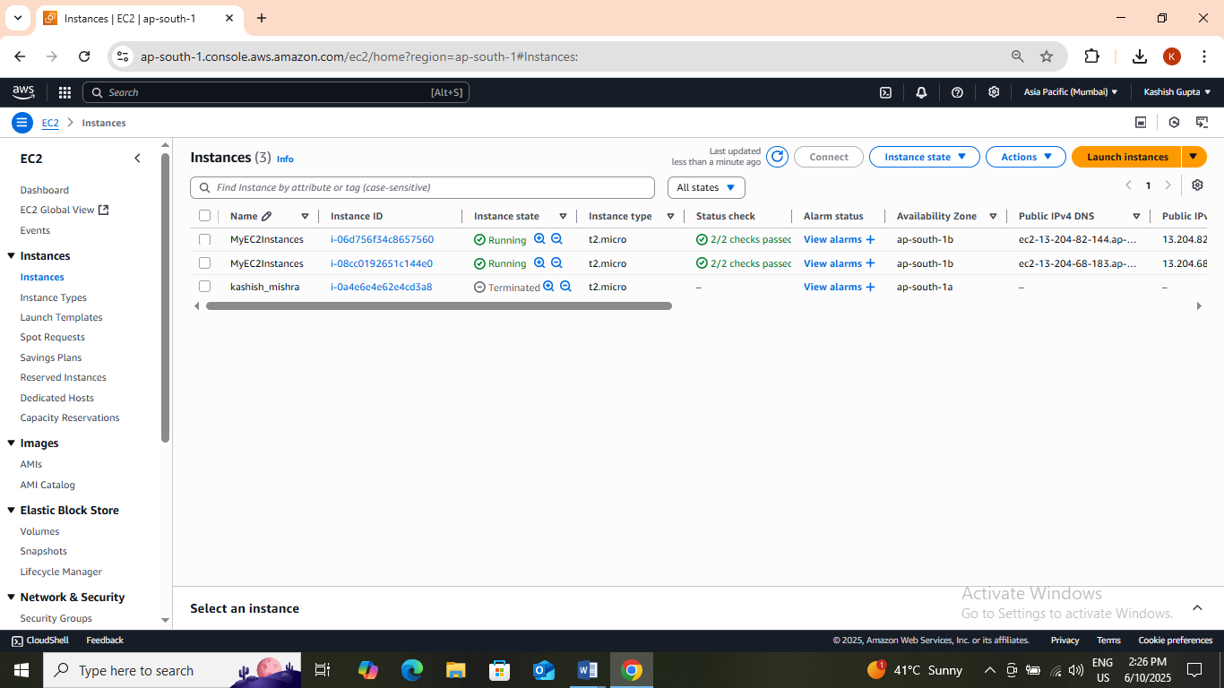

**Task 3:  Creating an Elastic File System**

1. .Navigate to **EFS** by clicking on the **Services**menu at the top. Click on **EFS**in the Storage section.
2. Click on **Create file system**
3. Click on **Customize** button.
4. Enter the details below, Type the **Name** as ***Myefsfile***.
5. In File system type , choose: **Regional.**
6. Uncheck the option of **Enable automated backups**
7. Leave everything by default and click on the **Next**button present below.

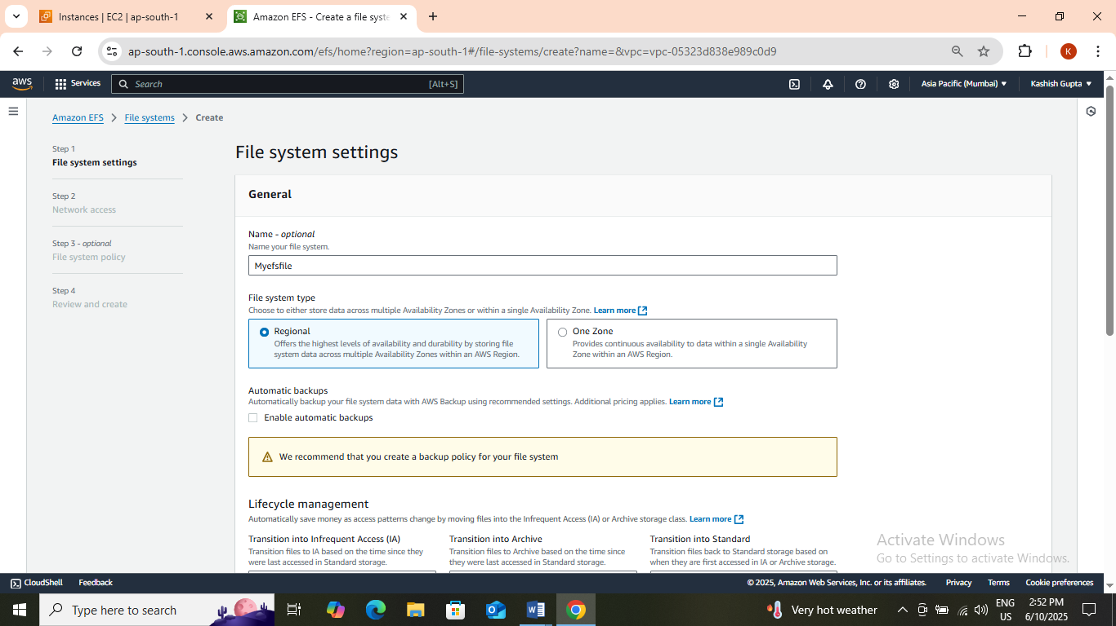

1. **Network Access**:

* **VPC**
  + An Amazon EFS file system is accessed by EC2 instances running inside one of your VPCs.
  + Choose the same VPC you selected while launching the EC2 instance (leave as default).
* **Mount Targets**
  + Instances connect to a file system by using a network interface called a mount target. Each mount target has an IP address, which we assign automatically or you can specify.
  + We will select **all the Availability Zones**(AZ’s) so that the EC2 instances across your VPC can access the file system.
  + Select all the Availability Zones, and in the Security Groups, select **EFS Security Group** instead of the default value.
  + Make sure you remove the default security group and select the EFS Security Group, otherwise you will get an error in further steps.
* Click on **Next**button

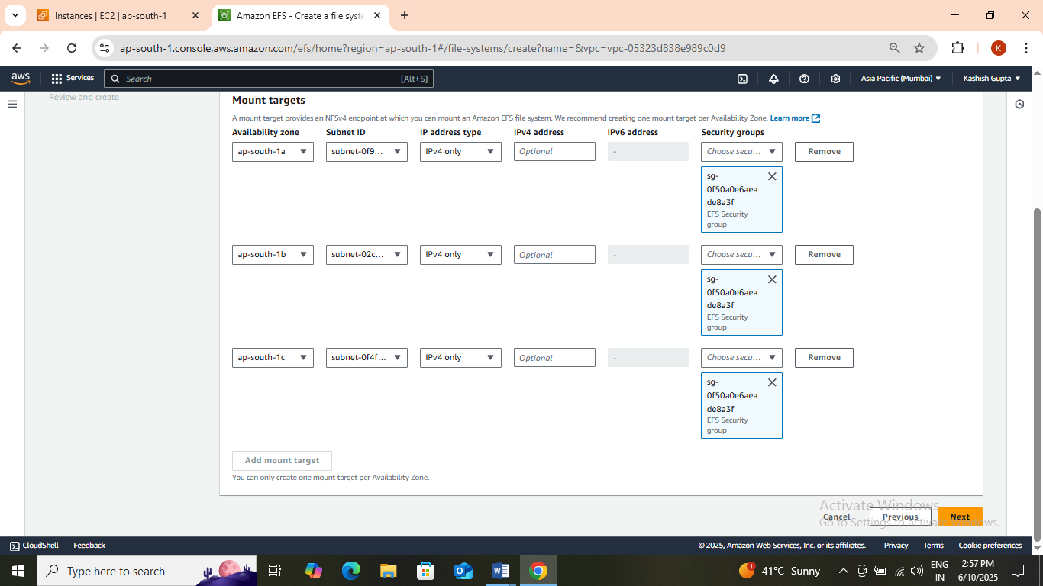

1. **File system policy - optional** let it be optional only. Click on **Next**button.
2. **Review and Create**: Review the configuration below before proceeding to create your file system. Click on **Create**button.
3. Congratulations on creating the EFS File system, It is the time to **mount** your EC2 Instance with the EFS File system.

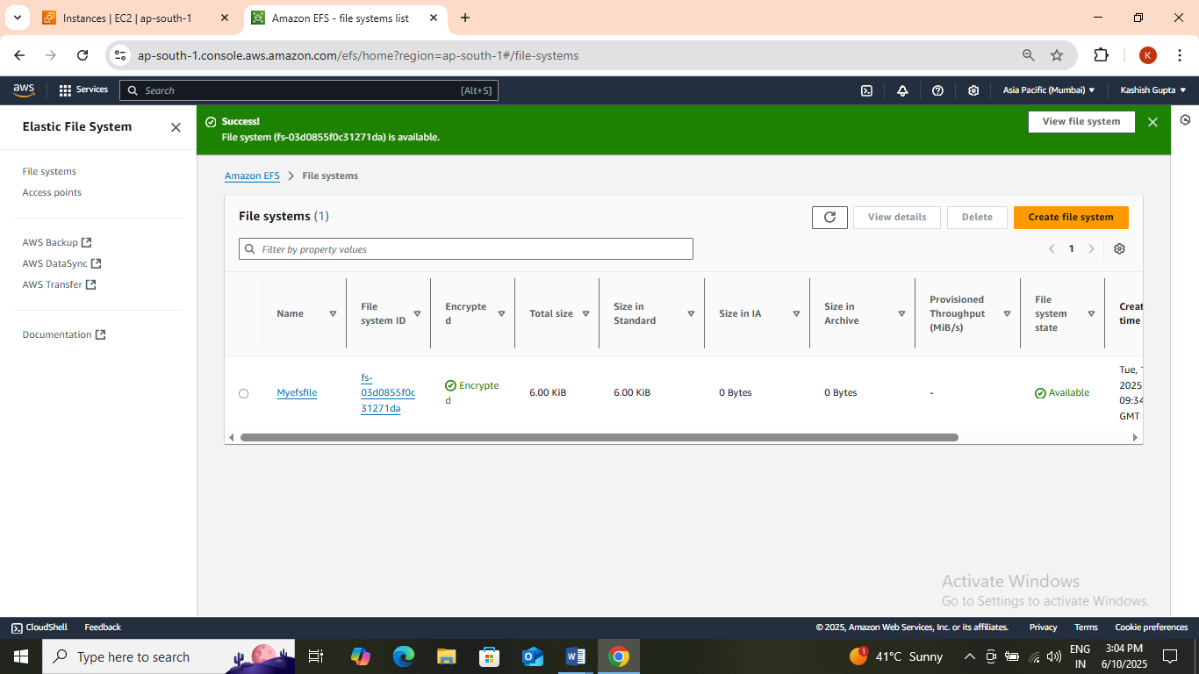

**Task 4: Mount the File System to MyEC2instance-1 Instance**

1. Select the MyEC2instance-1 Instance and copy the IPv4 Public IP.
2. SSH into the EC2 Instance

* Now follow one by one step in [SSH into EC2 Instance](https://www.whizlabs.com/labs/support-document/ssh-into-ec-instance).
* **sudo –s**
* **yum –y update**
* **yum install –y amazon-efs-utils**
* **mkdir efs**
* We have to mount the file system in this directory To do so, navigate to the AWS console and click on the created file system. On the top-right corner, click on **Attach**
* **sudo mount –t efs –o tls fs-03d0855f0c31271da:/ efs**
* **Note**: **fs-2ad0a9a8**is file system id in my case, it could be different in your case, make sure to **replace it.** To display information for all currently-mounted file systems, we'll use the command bellow.
* **df –h**
* **mkdir aws**

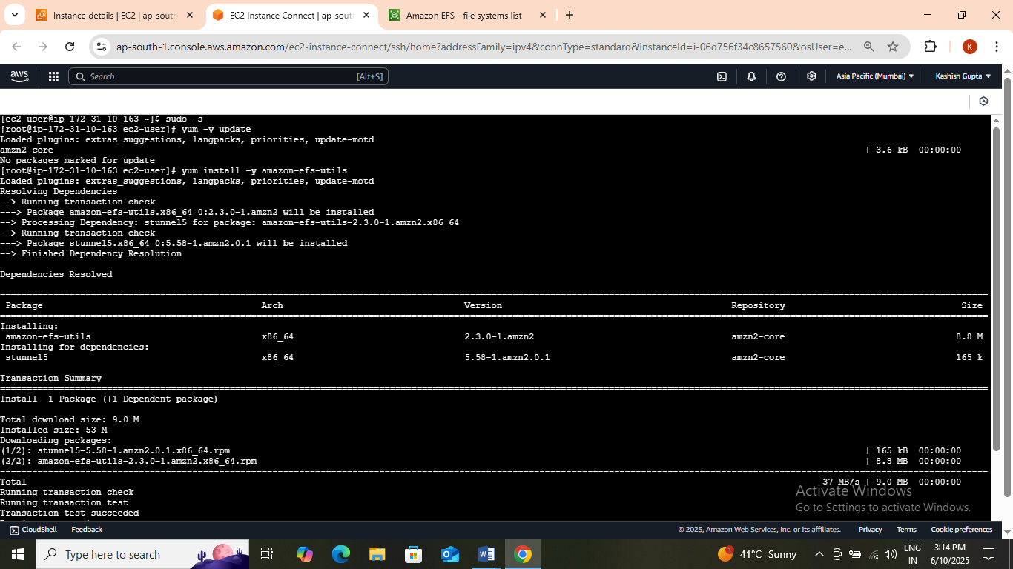

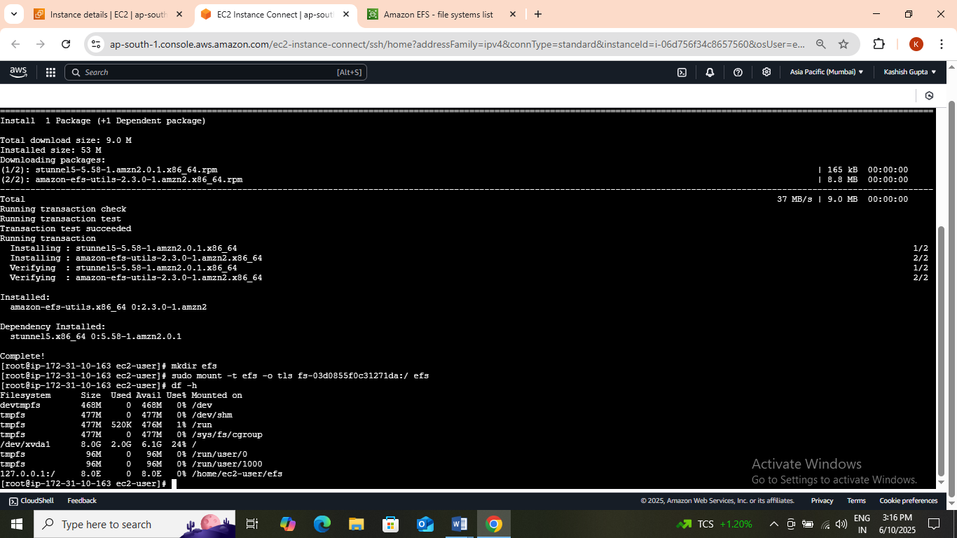

**Task 5: Mount the File System to MyEC2instance-2 Instance.**

1. Select the MyEC2instance-1 Instance and copy the IPv4 Public IP.
2. SSH into the EC2 Instance

* Now follow one by one step in [SSH into EC2 Instance](https://www.whizlabs.com/labs/support-document/ssh-into-ec-instance).
* **sudo –s**
* **yum –y update**
* **yum install –y amazon-efs-utils**
* **mkdir efs**
* We have to mount the file system in this directory To do so, navigate to the AWS console and click on the created file system. On the top-right corner, click on **Attach**
* **sudo mount –t efs –o tls fs-03d0855f0c31271da:/ efs**
* **Note1**: **fs-2ad0a9a8**is file system id in my case, it could be different in your case, make sure to **replace it.**
* **Note2:**In the above command we see, it starts with "**sudo"** since you are already a super-user, it's ok, if you don't remove **sudo.** To display information for all currently-mounted file systems, we'll use the command bellow.
* **df –h**
* **mkdir aws**

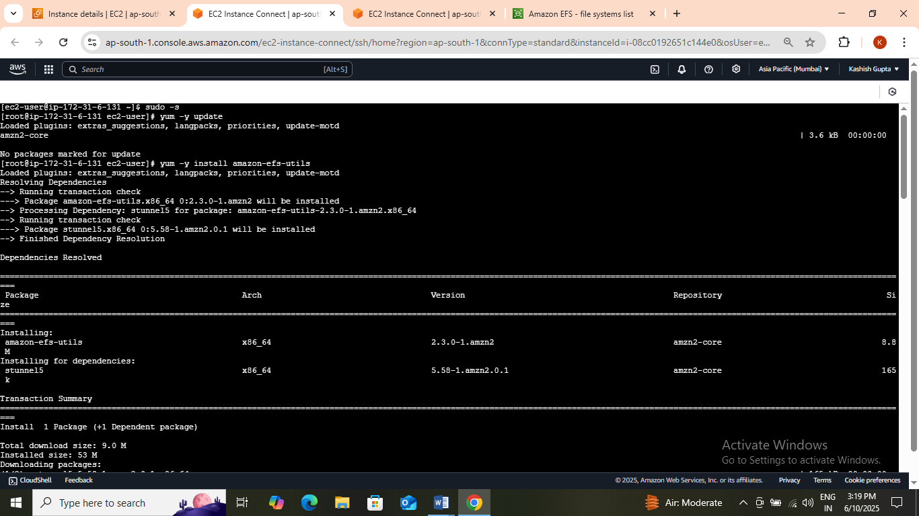

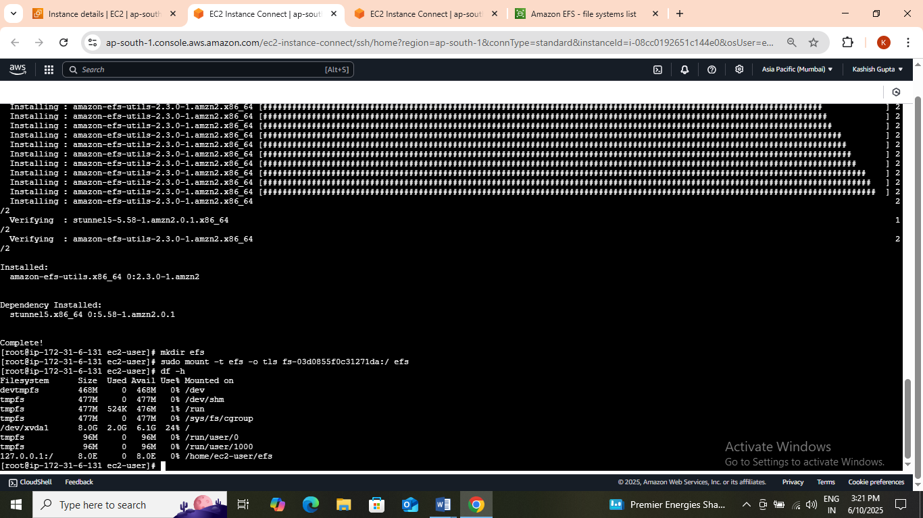

**Task 6: Testing the File System.**

1. SSH into both instances in a side-by-side view on your machine, if possible.

* Now follow these steps in both the instance.
* **sudo –s**
* **cd efs**
* **touch hello.txt**
* **ls –ltr**
* **cd efs**

1. You can see the file created on this server as well. This proves that our EFS is working.
2. You can try creating files (**touch**command) or directories (**mkdir**command) on other servers to continue to grow the EFS implementation.